Mbonu Somtochukwu

FACULTY OF COMPUTING

CYBER SECURITY

BHU/22/04/09/0027

CYB202

PROJECT 1

Project One

Objective

Design and implement a computer network for Bingham university, segmented based on different faculties. This includes planning the network topology, IP subnetting and configuration network devices.

Task

Identify all the faculties in Bingham University and their departments and present the information in the following format:

Table A

|  |  |  |
| --- | --- | --- |
| # | Faculty | Number of departments |
| 1 | Faculty of Computing | 3 |
| 2 | Faculty of ABC | N |
| 3 |  |  |

You are provided a network 192.168.4.0, you are required create subnets for each faculty with departments as the nodes (hosts).

1. State the number of bits you will borrow from the Host ID to create the required number of subnets.
2. Show the bits combinations that are possible from the number of bits borrowed in (a) above.
3. Using the information in (b) compute the range of values for each network (show your work)
4. Using a table, present the network ID, Host ID Range, Number of Usable Host IDs and Broadcast IDs for each of the networks as generated from (c) (Label this as Table B)
5. Based on the information in Table A, use packet tracer to design the physical network showing the network equipment for each segment of the network.
6. Use data in Table B, generated in (e) to implement the logical network.

Answers:

|  |  |  |
| --- | --- | --- |
| **#** | **Faculty name** | **Number of department** |
| 1 | Faculty of law | 1 |
| 2 | Faculty of computing sciences | 3 |
| 3 | Faculty of allied health | 2 |
| 4 | Faculty of education | 3 |
| 5 | Faculty of medical sciences | 7 |
| 6 | Faculty of arts | 3 |
| 7 | Faculty of pharmaceutical sciences | 1 |
| 8 | Faculty of environmental sciences | 5 |
| 9 | Faculty of science and technology | 8 |
| 10 | Faculty of social sciences | 4 |
| 11 | Faculty of business administration | 2 |

1. In this instance 4 bit where borrowed as we need “ 11 ” IP address. Borrowing 4 bits gave us 16 IP address but we will only use 11, derived by using 2^(4) = 16.
2. Table A

|  |  |  |
| --- | --- | --- |
| # | Faculty name | IP ADDRESS |
| 1 | Faculty of medical sciences | 192.168.4.16 |
| 2 | Faculty of Education | 192.168.4.32 |
| 3 | Faculty of Environmental Science | 192.168.4.48 |
| 4 | Faculty of Social Sciences | 192.168.4.64 |
| 5 | Faculty of Pharmaceutical sciences | 192.168.4.80 |
| 6 | Faculty of Computing Science | 192.168.4.96 |
| 7 | Faculty of Allied-Health | 192.168.4.112 |
| 8 | Faculty of Arts | 192.168.4.128 |
| 9 | Faculty of Business Administration | 192.168.4.144 |
| 10 | Faculty of law | 192.168.4.160 |
| 11 | Faculty of Science and Technology | 192.168.4.176 |

1. The range of values for the network will be 16, as we borrowed 4 bits from the host ID.

2^(4) = 16 IP addresses.

We will on line use 14 IP address from this 16 as we exempt two for the “ Broadcast ID” and the “ Network ID “.

1. Table B

|  |  |  |  |  |  |
| --- | --- | --- | --- | --- | --- |
| # | Faculty name | Network_IDs | Range | Usable host_Ids | Broadcast_IDs |
| 1 | Faculty of medical sciences | 192.168.4.2 | 192.168.4.1 - 192.168.4.14 | 14 | 192.168.4.15 |
| 2 | Faculty of Education | 192.168.4.16 | 192.168.4.17 - 192.168.4.30 | 14 | 192.168.4.31 |
| 3 | Faculty of Environmental Science | 192.168.4.32 | 192.168.4.33 - 192.168.4.46 | 14 | 192.168.4.47 |
| 4 | Faculty of Social Sciences | 192.168.4.48 | 192.168.4.49 - 192.168.4.62 | 14 | 192.168.4.63 |
| 5 | Faculty of Pharmaceutical sciences | 192.168.4.64 | 192.168.4.65 - 192.168.4.78 | 14 | 192.168.4.79 |
| 6 | Faculty of Computing Science | 192.168.4.80 | 192.168.4.81 - 192.168.4.94 | 14 | 192.168.4.95 |
| 7 | Faculty of Allied-Health | 192.168.4.96 | 192.168.4.97 - 192.168.4.110 | 14 | 192.168.4.111 |
| 8 | Faculty of Arts | 192.168.4.112 | 192.168.4.113 - 192.168.4. 126 | 14 | 192.168.4.127 |
| 9 | Faculty of Business Administration | 192.168.4.128 | 192.168.4.129 - 192.168.4.142 | 14 | 192.168.4.1143 |
| 10 | Faculty of law | 192.168.4.144 | 192.168.4.145 - 192.168.4.158 | 14 | 192.168.4.1159 |
| 11 | Faculty of Science and Technology | 192.168.4.160 | 192.168.4.161 - 192.168.4.174 | 14 | 192.168.4.175 |

We only have 14 usable IP addresses because we must reserve two from the available IP address for the broadcast and network ID’s.

2^(B) - 2 = usable IP address.

where B is bits borrowed.

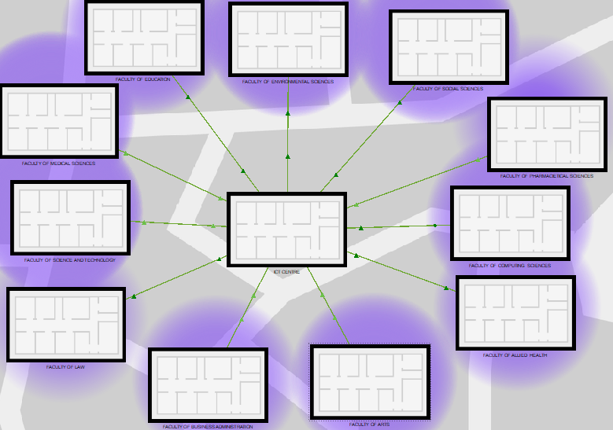

This is the “ Physical View “ of the university.

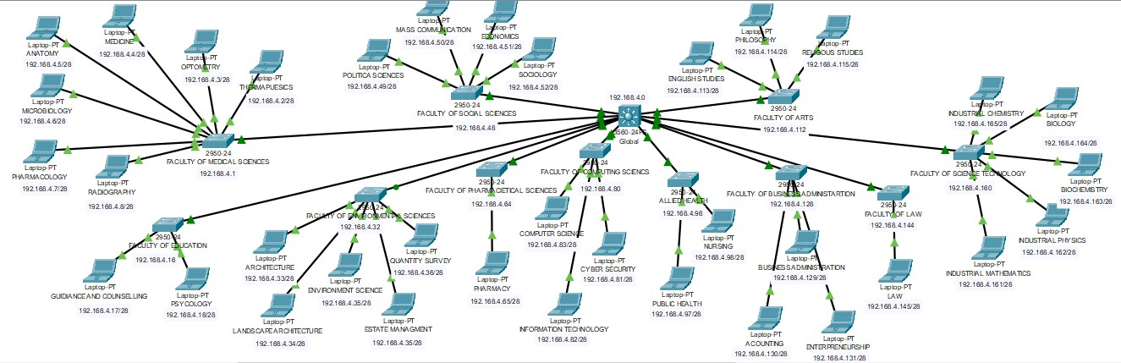

This is the “Network View “ of the University, In this instance we use a star topology from the ICT Centre **“** Multi-layer Switch” at the center which is then connected to “ layer-2 Switch ” in each Faculty and finally distributed to “Access points” for department.

Here we used the following devices:

- Multi-layer : 3560-24ps (Core layer)

- Multi-layer : 3560-24ps (Distribution layer)

- layer2 Switch : 2950-24 (Access layer) (11 for the 11 Faculty)

- layer 1 device : Access-Point-PT (Endpoint User)(For each department, NODES)

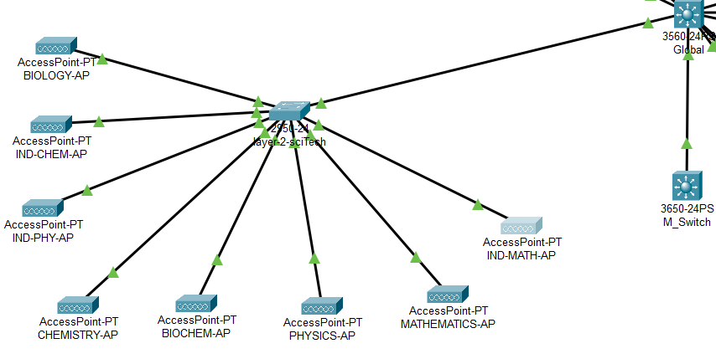

We will use this as case study for the explanation of the logic network.

. **First what devices were used and why?**

Here we used the following devices:

**Core Layer: Cisco Catalyst 3560-24PS**

* **Role:** The backbone of the network, handling high-speed data transfer between different network segments.
* **Function:** Connects the distribution layer switches and other core devices, providing high availability and redundancy.
* **Why used:** Handles heavy traffic, ensuring fast and reliable communication across the entire network.

**Distribution Layer: Cisco Catalyst 3560-24PS**

* **Role:** Intermediate layer between the core and access layers.
* **Function:** Aggregates traffic from multiple access layer switches, providing network segmentation and policy enforcement.
* **Why used:** Improves network scalability, manageability, and security.

**Access Layer: Cisco Catalyst 2950-24**

* **Role:** The edge of the network, connecting end-user devices to the network.
* **Function:** Provides connectivity to workstations, servers, and other devices.
* **Why used:** Offers reliable and cost-effective connectivity for end users.

**Endpoint User: Access Point-PT**

* **Role:** Wireless access point for connecting wireless devices to the network.
* **Function:** Provides Wi-Fi connectivity to laptops, smart-phones, and other wireless devices.
* **Why used:** Enables mobile users to access the network without physical cabling.

. The logic:

For each Range of IP_Addresses 2 can not be used which leave use with 14 IPs left.

Consider the example A from “Table B”:

|  |  |  |  |  |
| --- | --- | --- | --- | --- |
| # | Faculty of Science and Technology | 192.168.4.160 | 192.168.4.161 - 192.168.4.174 | 192.168.4.175 |

In the above slot,

- Network_Id : “192.168.4.160 ”,

- Range : “ 192.168.4.161 - 192.168.4.174 ”

- Broadcast_Id : “ 192.168.4.175 ”

Configurations were made in each layer to create VLANs to connect the Core to the Distribution layer, And the Distribution to the Access Layer.

Using a VLANs, in this case (name : “ VLAN110 “ ), we created a VLAN for each **Faculty**  and allocated an IP_Address to each VLAN.

- Core Layer: Cisco Catalyst 3560-24PS(Configuration):

**”””**

**.enable**

**.configure terminal**

**.ip routing**

**.vlan 110**

**.hostname core**

**.name Faculty_SciTech  
.interface vlan 110**

**.ip address 192.168.4.161 255.255.255.240**

**.no shutdown  
”””**

This Created a VLAN in the **Core layer,** and through an ethernet cable the **Core** Device was connected the **Distribution layer device**.  
**- ”””**

**.enable**

**.configure terminal**

**.vlan 110**

**. interface FastEthernet0/1**

**.ip address 192.168.4.162 255.255.255.240**

**.switchport mode trunk**

**.switchport trunk allowed vlan all**

**”””**

This allocated the vlan to a Specific “PORT, in the case ”FastEthernet0/1, on the **Distribution layer** Device which where then connected to the **Access layer devices**. This process would be repeated for all 11 Faculties.

**-“””**

**enable**

**configure terminal**

**vlan 10**

**name Faculty1**

**vlan 20**

**name Faculty2**

**# ... continue for other faculties  
”””**

Finally the **Access layer devices** would be configure.

“””

**interface FastEthernet0/1**

**switchport mode access**

**switchport access vlan 110**

**vlan 110**

**name Faculty1**

**ip address 192.168.4.163 255.255.255.240**

“””

So to reduce errors rather than use a “DHCP server”in this switch and conned that device to switch nodes for each department, I used access point.

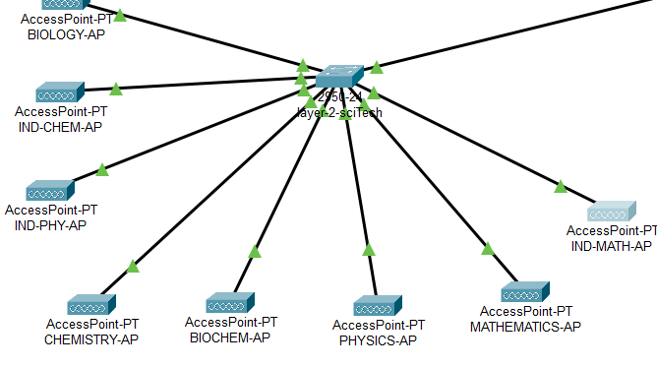

Where Each **Access Point** is a node, and does not need configuration. Also each **Access point** can take max of 100 users. These **Access Points** can be connected to all devices.

. **Explanation of trunk and use:** A trunk is a link between two network devices (typically switches) that can carry multiple VLANs simultaneously. It's like a highway with multiple lanes, each lane carrying different types of traffic (VLANs).